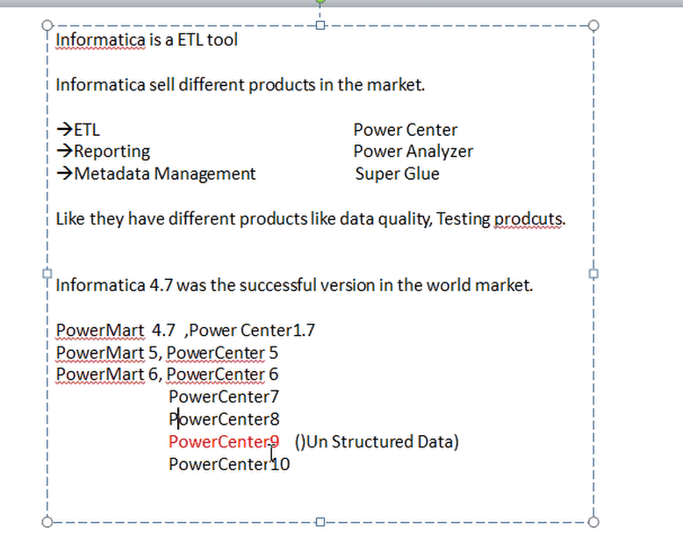

Upto version 7, it is client server architecture.

From version 8, service oriented architecture

Client(Power Center Client)

-------

Power center designer(Mapping desinger)

work flow manager (session) -🡪 defining and trigger, scheduling session

work flow monitor -🡪 monitoring the jobs.

repository manager -🡪 admin activities like adding users, setting permissions, changing passwords etc

Repository Service and Integration Service

Repository Service 🡪 It acts as a bridge between the repository and Integration Service. It inserts,updates, deletes the metadata

Integration Service -🡪 All the requests are sent to Integration service

Row by row processing

Service oriented architecture : if server is down, all jobs get aborted. So we have Domain and node.if one node fails, all the jobs are directed to other nodes in domain by maintain high availability. Number of nodes can be increased. Scalability is available in SoA.

Default 3 node in SoA

Node : logical representation of server

SLA: Servicev Level Agreement

Mapping designer has 5 components (Source Analyzer, Target Designer, Mapping Designer)

Workflow Manager has Task Developer,Worklet Designer and Workflow designer

Mapping or Program -🡪 graphical UI for pulling data from source to target

Power exchange developed by Informatica for reporting purposes

server

-------

repository service

integration service

oracle e delivery

router transformation

filter transformation

Real time, we can access only the client

Trnsformations : power center repository object

Active transformation: if there is difference between input andoutput no of records, it is called active transformation

Passive transformation: no difference

Column level transformation : all active transformations are column level transformations

Row level transformation :

Joiner transformation

Normaliser transformation ; does the pivot operation;occurences should be increased;occurrences will accept 6 input ports. GK(Surrogate key) and GCID are created, GCID will help us to get different attribute names based on occurences

Aggregation transformation :sum🡪 It’s like a group by

Expression transformation

Rank Transformation 🡪 Ports, group by options

Main Frame System generates cobol files. Only normalizer transformation can read data from cobol files

Iif for if condition in informatica

Iif(a=b,true,false)

2 different types of flat files🡪Fixed width, delimited file

Reusable transformations

On succeeded in workflow manager , decision task, assignmemt task,event wait task, event raise,timer task,Control(fail me, fail parent, fail top level workflow)task

Workflow level variable used across session.

Mapping level variables are specific for a mapping

Workflow run

Output field names, append if exists, bad file data

Sources -🡪 Import from file, start import from row1, Mapping tab

Source File type Direct, Indirect 🡪 similar to dynamic schema 🡪 list file

Sequence generator transformation🡪 Start value, Increment by, end value, current value, reset the values manually or in a cycle

Union, lookup

Modulus function

Data preview

Disable

Status of workflow. Suspend on error🡪 If any job fails in the workflow, it will go to suspend mode.

Recover the suspended job is possible.

To Restart the job, the job shoulbe aborted.

Parameter file fromnsession level and workflow level. Workflow and sessionlogs will created in server directory. Work by runs and timestamp are available. Hard ware recovery

Dimension : descriptive info about particular object

Generate query

Update Strategy Transformation

Mapplet is the collection of reusable objects.

Nested mapplet is not possible

Normaliser and stored procedure transformations cannot be used in the maplet

BW param

Lookup transformation 🡪 Connected and Unconnected Lookup

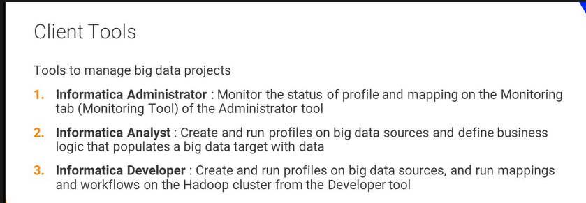

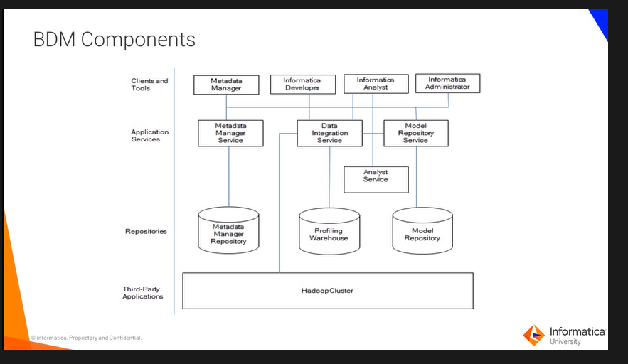

Cache : temporary memory for runtime data

Static cache

Persisent cache

Dynamic cache

Unconnected lookup helps in performance instead of connecting unnecessary to multiple areas

Union Transformation

Informatica Power Center?

Mapping

Workflow

Joiner, router, filter transformations

Dynamic mapping

Parameter sets